**DAILY ONLINE ACTIVITIES SUMMARY**

|  |  |  |  |
| --- | --- | --- | --- |
| **Date:** | 24/06/2020 | **Name:** | Krishnitha |
| **Sem & Sec** | 4th sem, A Section | **USN:** | 4AL18CS039 |
| **Online Test Summary** | | | |
| **Subject** | NA | | |
| **Max. Marks** | NA | **Score** | NA |
| **Certification Course Summary** | | | |
| **Course** | Web Development Engineer | | |
| **Certificate Provider** | AWS Educate | **Duration:** | 3 hrs |
| **Coding Challenges** | | | |
| **Problem Statement:** NA | | | |
| **Status:** Executed | | | |
| **Uploaded the report in GitHub** | | YES | |
| **If yes Repository name** | | -- | |
| **Uploaded the report in slack** | | YES | |

**Certification Course Details:**

Today I completed the two modules of the course “Web Development Engineer” by AWS Educate i.e., ‘Software development in web, mobile and gaming’ and ‘Data and Databases’. I have also completed the assessment of these modules.

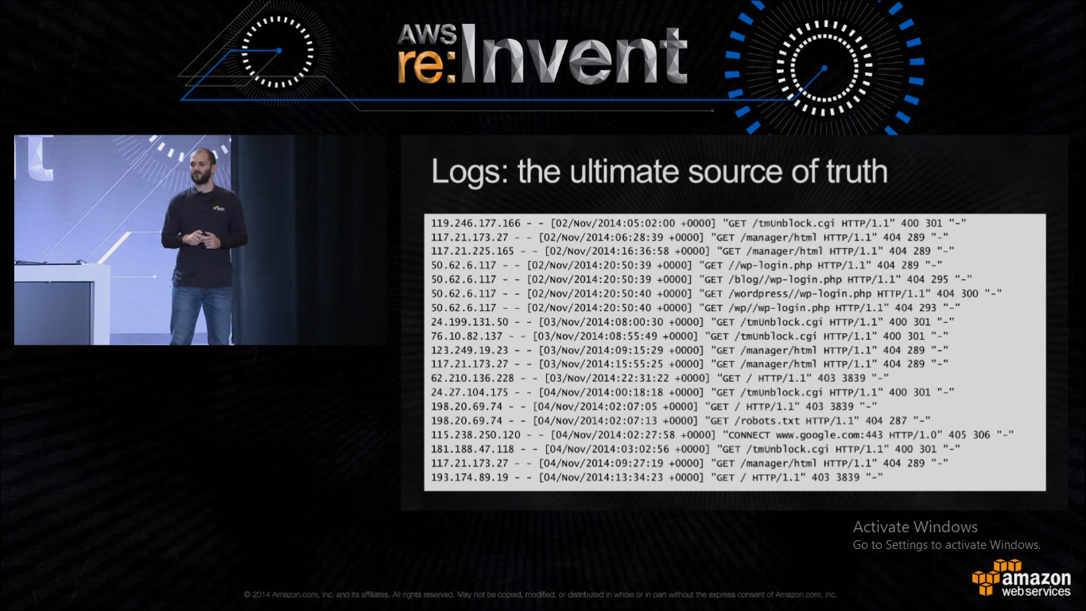

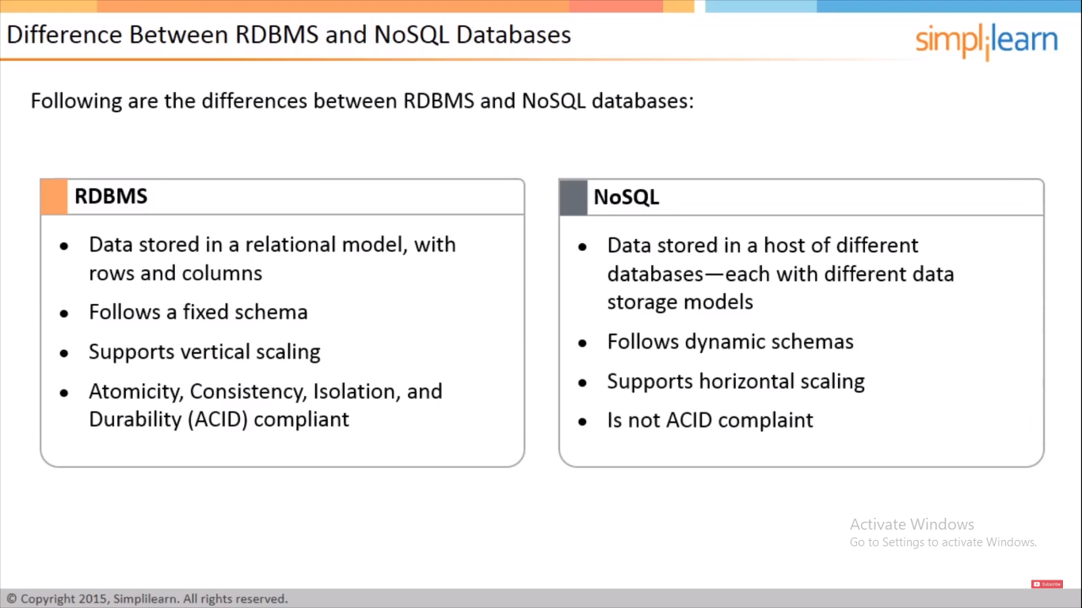

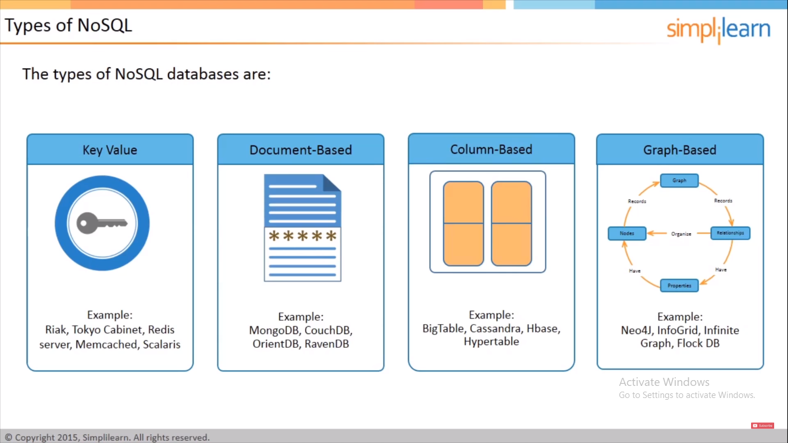

**Webinar Details:**

Today I have attended the webinar on C programming by Assistant Professor Ms. Megha.D.Hegde, CSE department- AIET. There was assessment conducted based on the webinar. There were 15 number of questions of ONE mark each out of which I scored 11.

